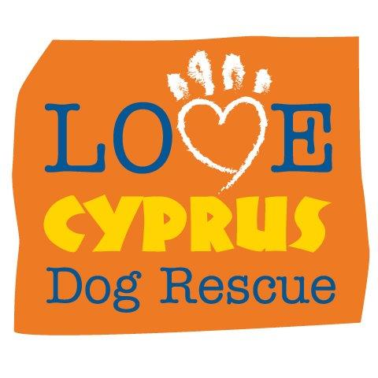 Love Cyprus Dog Rescue (LCDR)
UK Registered Charity Number 1162877
Standing Order Form

Please print where possible:
Your First & Surname:

Home Address :

Post Code:

If you want to give us your Email address :

INSTRUCTION to your Bank or Building Society to pay by Standing Oder:

Here is my monthly gift of £ ___ Please debit my account each month, starting on the : __/__/__

Your Bank or Building Society details:
To: The Manager, _________________________ Bank/ Building Society

Address: _________________________________________________________________________________________

Account Name. : ____________________________ Account Number: __________________ Sort Code: __________

Your Signature (s) : __________________________________ ____________________________________

Please pay to Love Cyprus Dog Rescue (LCDR) the monthy amount from our above account. I understand this instruction may remain with LCDR and details will be passed to my Bank/Building Society. Their bank details are:

Barclays Bank, 18, Southgate Street, Gloucester. GL1 2DH Account No: 03909204 Sort Code: 20-33-83

GIFT AID - if you pay UK income or capital gains tax, LCDR can re-claim the tax you paid or will pay on past and future donations back from the Government (up to the amount you paid). All you have to do is tick and date a box !

I agree that LCDR can treat all donations I have made since April 2015 and all future donations I
make from the date of this declaration (until I notify otherwise), as Gift Aid donations.

I agree ! Tick box and date: tick Date :
_ / / 20
/ / 20

Please send completed forms to :
Louise James, The Coppice, Compton Green, Redmarley, Gloucs GL19 3JB
Our E-mail address is: lovecyprusdogrescue@gmail.com

